#### **Uploading and Downloading file**

**to Azure File storage in NAV 2016**

1. **Create Azure Blob Storage**

The section contains the guidelines on how to Create Azure Blob Storage.

* Open [Portal.Azure.com](https://login.microsoftonline.com/common/oauth2/authorize?resource=https%3a%2f%2fmanagement.core.windows.net%2f&response_mode=form_post&response_type=code+id_token&scope=user_impersonation+openid&state=OpenIdConnect.AuthenticationProperties%3dZmNLpG5-PQSMJvfKiX_jeFiJyS9i2AF7oI6t0nItXDggUavm971toIAvZYq0EsH5PZCib5Jz_e74XpCP7ySFSsd7Ic5lo5u8iR-uGecFJlRg9V-T86z3124uwDCLXBxsPrc0F0tszG8xn_f2HFXTKMmVsdXeRwA8xIaE9LFSMsAuzeyhVgWYthzJ-pJ1yUIsKvGGK07KuV1ncGKka8aCccAJDqpRrvxmk1dFmUs597w&nonce=636901293751289384.MmVkYjExZmUtOThiYS00NDYwLTg3YmYtZDk1NWUzOTVjNzNkZWUyOGU1MjEtNDY5Mi00MTRmLTk0ODktYzE3OTJhNzgwYjMz&client_id=c44b4083-3bb0-49c1-b47d-974e53cbdf3c&redirect_uri=https%3a%2f%2fportal.azure.com%2fsignin%2findex%2f&site_id=501430&client-request-id=76dec264-ff4f-49a5-840a-d4f11fe8dd17&x-client-SKU=ID_NET&x-client-ver=1.0.40306.1554).
* Navigate to Storage Account.

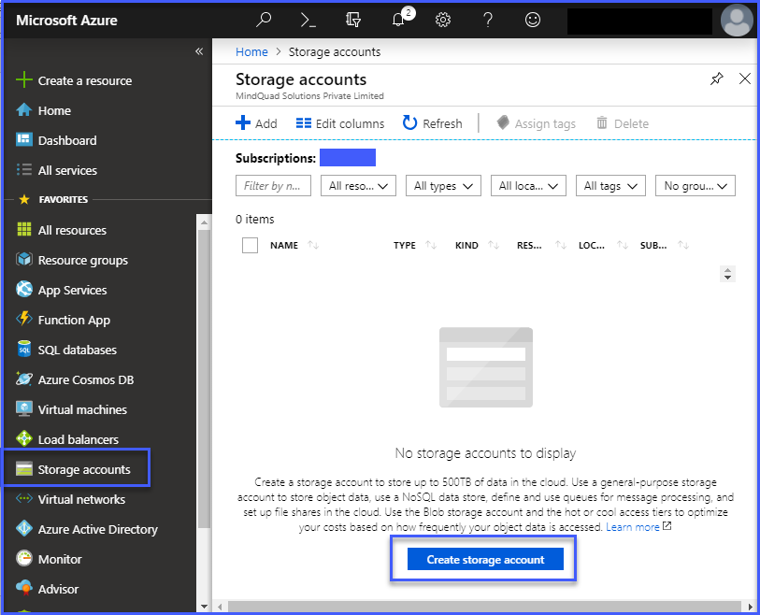

* Click on Create Storage account

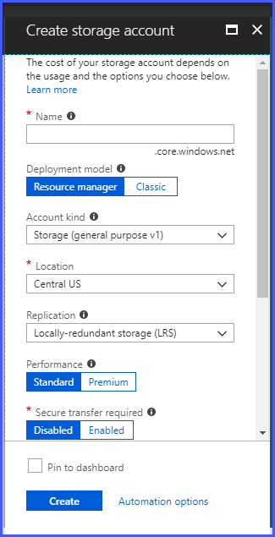

* Navigate to Blob Section as shown below

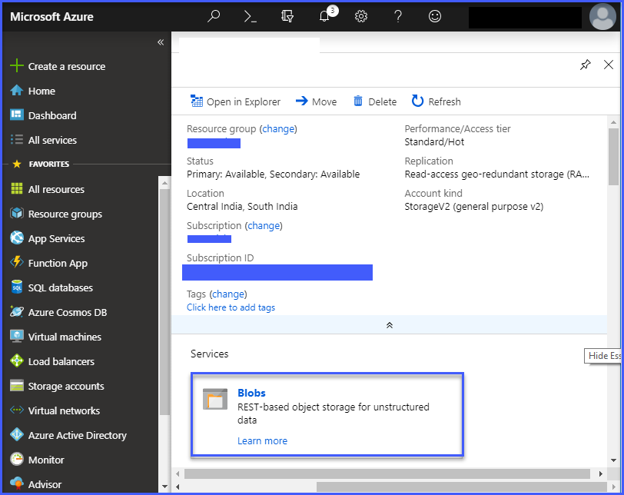

* Next Create Container for the Blob to Add files into the Container using Upload Button as shown below.

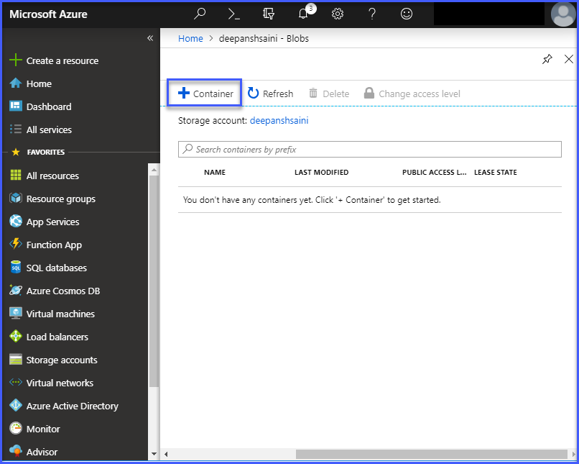

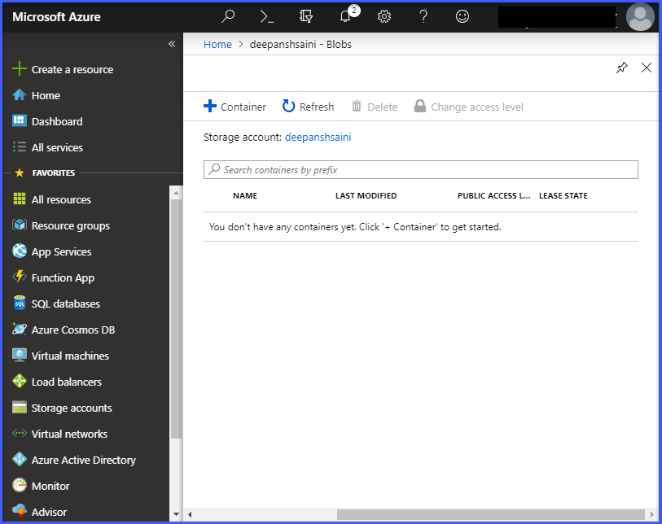

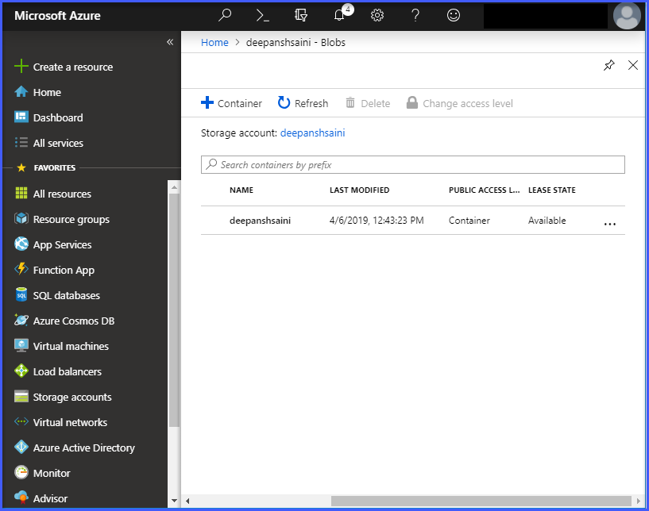

* Navigate to Storage Account (Which you created) -> Access Key , Copy Connection string which is used to connect Blob

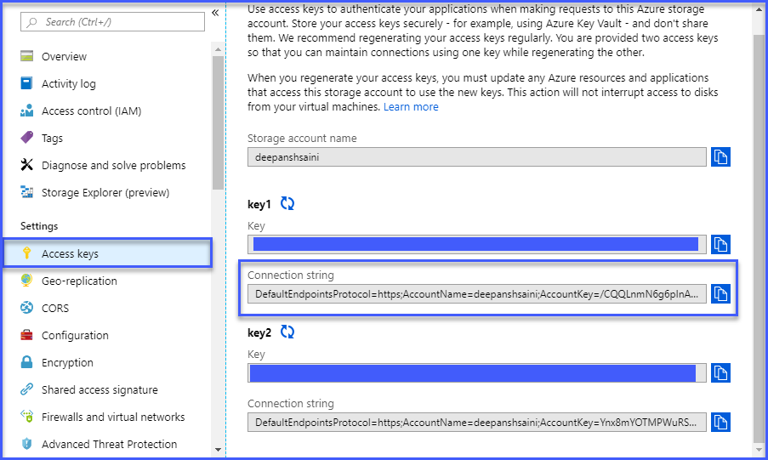

1. **Upload File into Azure Blob**
   * Add the Required reference using [Nuget](https://www.nuget.org/packages/Microsoft.Azure.Storage.Blob/)
   * **Install - Package Microsoft.Azure.Storage.Blob in Visual Studio >> Package Manager Console**
   * **Install-Package Microsoft.Azure.Storage.Common in Visual Studio >> Package Manager Console**

**Step 1. Run Microsoft Visual Studio**

**Step 2. On the list, find Class Library (.NET Framework) and click on Next Action**

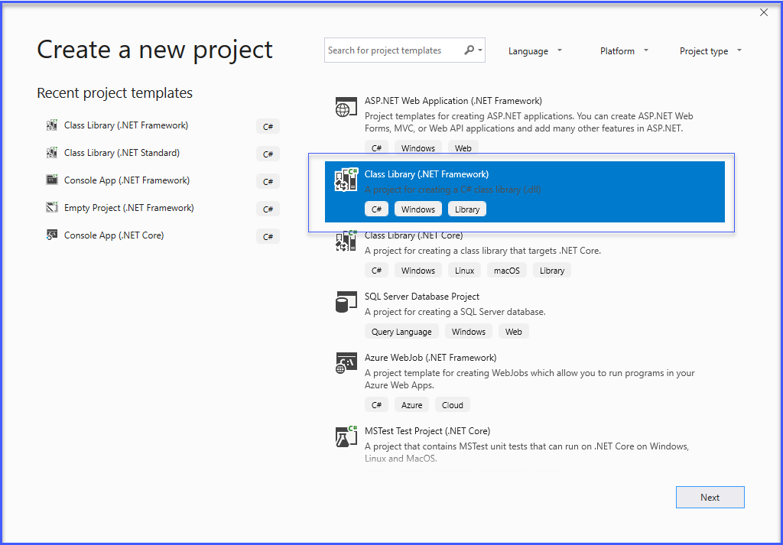

**Step 3. And Set the Project Name in Project Name Field and Click on Create Action.**

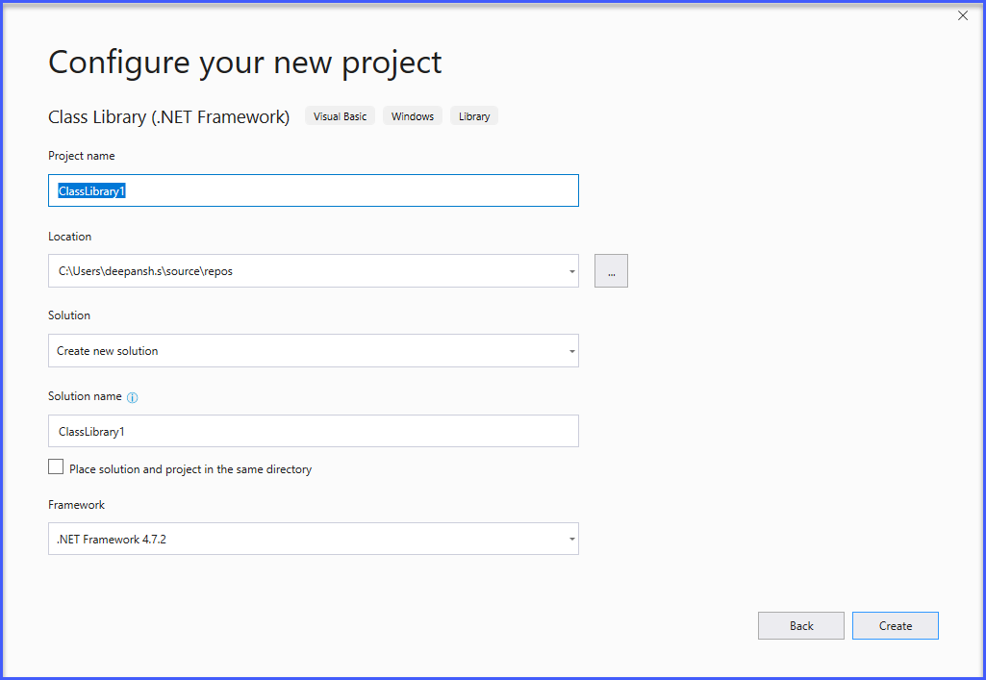

1. **Add the following code for upload file**

using Microsoft.WindowsAzure.Storage;

using Microsoft.WindowsAzure.Storage.Blob;

using System;

using System.Collections.Generic;

using System.IO;

using System.Linq;

using System.Text;

using System.Threading.Tasks;

namespace AzureBlob

{

public class AzureUpload

{

public string UploadBlob(string FileName, string FilePath, string AccountName, string AccountKey, string Container)

{

string Message = "";

try

{

var storageAccount = CloudStorageAccount.Parse("DefaultEndpointsProtocol=https;AccountName=" + AccountName + ";AccountKey=" + AccountKey + ";EndpointSuffix=core.windows.net");

var myClient = storageAccount.CreateCloudBlobClient();

var container = myClient.GetContainerReference(Container);

container.CreateIfNotExists(BlobContainerPublicAccessType.Blob);

var blockBlob = container.GetBlockBlobReference(FileName);

using (var fileStream = System.IO.File.OpenRead(FilePath))

{

blockBlob.UploadFromStream(fileStream);

}

Message = " File Upload Successfully";

}

catch (Exception ex)

{

Message = ex.Message.ToString();

}

return Message;

}

1. **Add the following code for Download file.**

public string DownloadBlob(string FileName, string FilePath, string AccountName, string AccountKey, string Container)

{

string Message = "";

try

{

var storageAccount = CloudStorageAccount.Parse("DefaultEndpointsProtocol=https;AccountName="

+ AccountName + ";AccountKey=" + AccountKey + ";EndpointSuffix=core.windows.net");

var myClient = storageAccount.CreateCloudBlobClient();

var container = myClient.GetContainerReference(Container);

container.CreateIfNotExists(BlobContainerPublicAccessType.Blob);

var blockBlob = container.GetBlockBlobReference(FileName);

MemoryStream memStream = new MemoryStream();

blockBlob.DownloadToStream(memStream);

FileStream file = new FileStream(FilePath, FileMode.OpenOrCreate, FileAccess.Write);

memStream.WriteTo(file);

file.Close();

memStream.Close();

Message = " File Download Successfully";

}

catch (Exception ex)

{

Message = ex.Message.ToString();

}

return Message;

}

1. **Add the following code for Delete file.**

public string DeleteBlob(string FileName, string AccountName, string AccountKey, string Container)

{

string Message = "";

try

{

var storageAccount = CloudStorageAccount.Parse("DefaultEndpointsProtocol=https;AccountName=" + AccountName + ";AccountKey=" + AccountKey + ";EndpointSuffix=core.windows.net");

var myClient = storageAccount.CreateCloudBlobClient();

var container = myClient.GetContainerReference(Container);

container.CreateIfNotExists(BlobContainerPublicAccessType.Blob);

var blockBlob = container.GetBlockBlobReference(FileName);

blockBlob.Delete(DeleteSnapshotsOption.IncludeSnapshots);

Message = "File Deleted Successfully";

}

catch (Exception ex)

{

Message = ex.Message.ToString();

}

return Message;

}

**Step 4. When you have prepared your code, you have to build your project. Click on Build tab and then Build Solution. You can also use a shortcut key (Ctrl + Shift + B) to do this.**

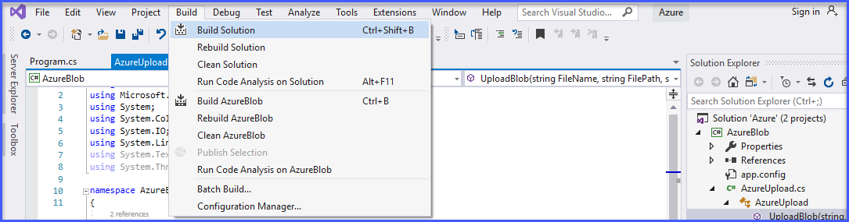

**Step 5. After build, you have to find your .NET Framework library on .dll file. Right-click on the project name in Solution Explorer and select Open Folder in File Explorer. Then go to bin/debug catalog, where you can find your .NET library. Copy this file.**

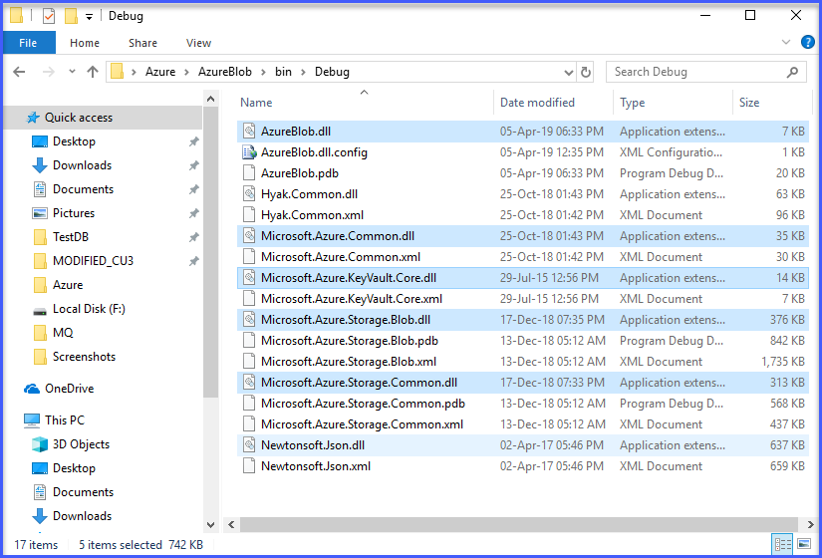

**Step 6. Go to Dynamics NAV catalog (look at this screenshot) and paste your files.**

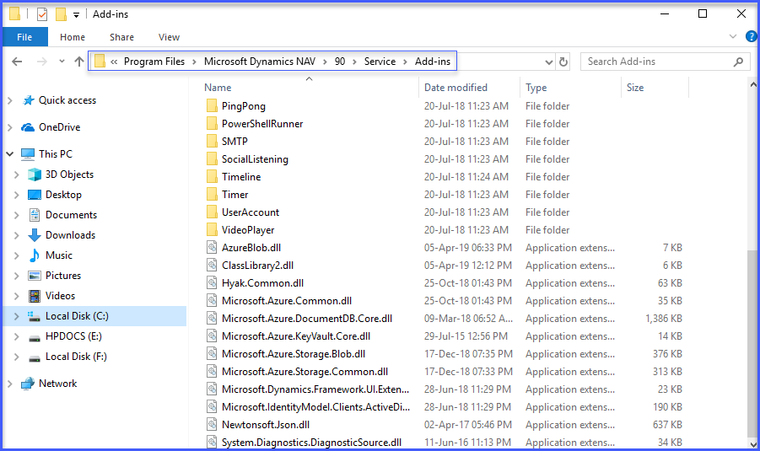

**Step 7. Added Four fields on Company Information for Fill azure account information show in screenshot**

1. **Account Name**
2. **Account Key**
3. **Container**
4. **Download Path**

* **Fill all information related Azure Account in Company Information.**

1. **Account Name - <Enter Your Azure Blob Account Name>**
2. **Account Key - <Copy Key from your Azure Blob storage account key >**
3. **Container - <Enter your Container name >**
4. **Download Path - <Enter Download Path>**

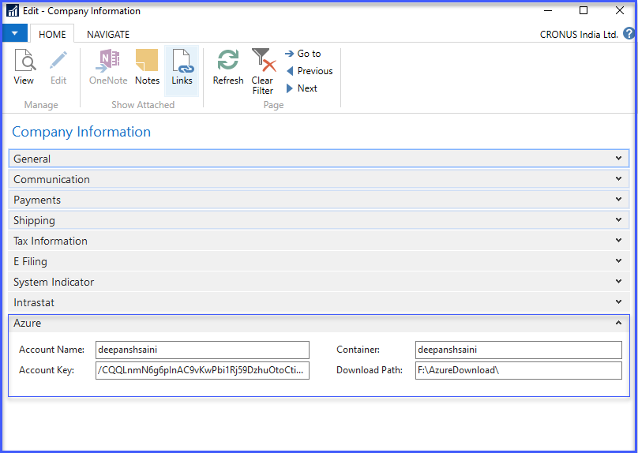

**Step 8. Run Microsoft Dynamics NAV and create a new table add fields show in screenshot.**

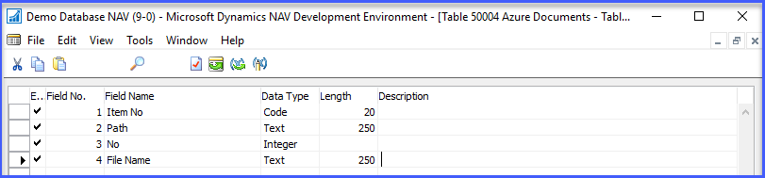

* **Set Primary Key**

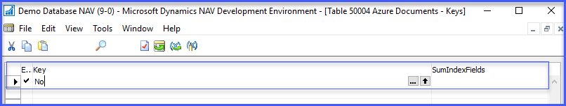

* **After that set Property of No. Field**

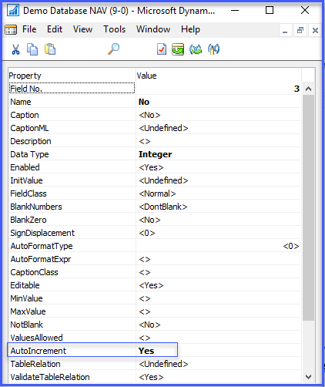

**Step 9. create a new page and set properties show in screenshot.**

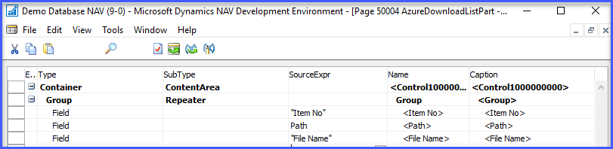

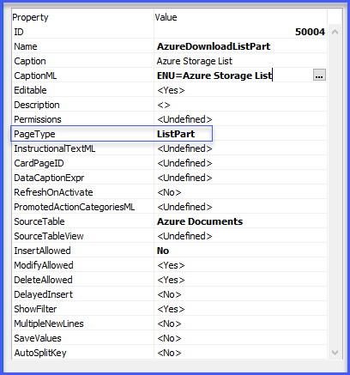

**Step 10. After that added variables and functions**

* **And add these all Global variable (look at this screenshot)**

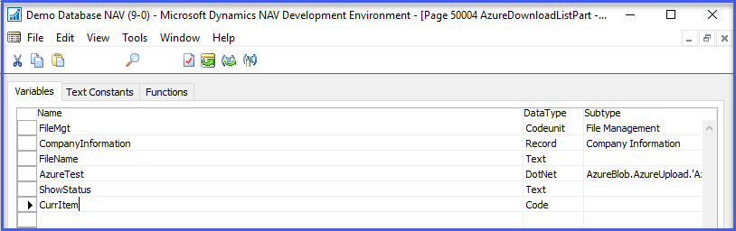

* **After that add two Functions (Look at this screenshot)**

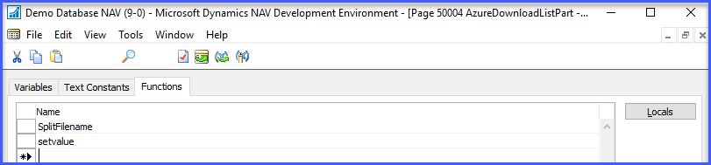

* **Add parameter of SplitFilename function**

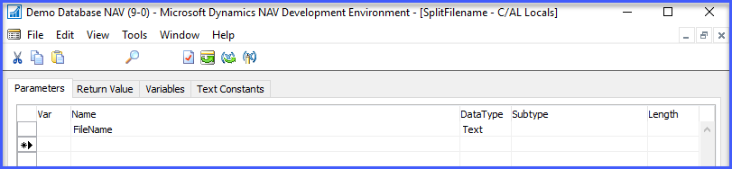

* **Add Local Variable in this Function**

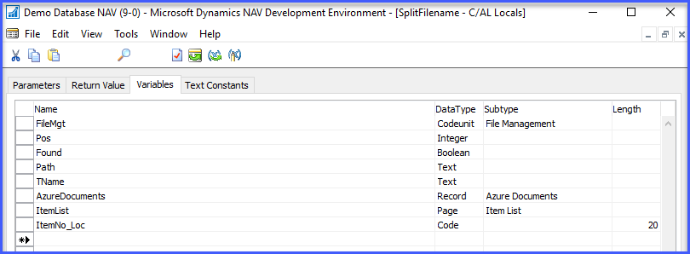

**For DotNet - Then you have to declare a new variable with DotNet DataType**

**In Subtype field, press F6 and go to the Assembly by clicking an arrow icon. Find your file.**

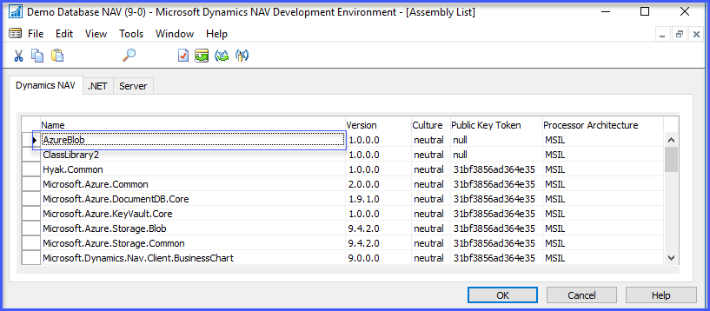

* **Add parameter of setvalue function**

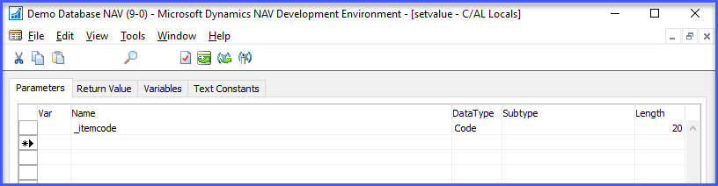

* **Added Code in SplitFilename Function**

Path := '';

TName := '';

FileName := DELCHR(FileName,'<>');

IF (FileName = '') THEN

EXIT;

Pos := STRLEN(FileName);

REPEAT

Found := (COPYSTR(FileName,Pos,1) = '\');

IF NOT Found THEN

Pos := Pos - 1;

UNTIL (Pos = 0) OR Found;

IF Found THEN BEGIN

Path := COPYSTR(FileName,1,Pos);

TName := COPYSTR(FileName,Pos+1);

END ELSE BEGIN

Path := '';

TName := FileName;

END;

AzureDocuments.INIT;

AzureDocuments."Item No" := CurrItem;

AzureDocuments.Path := Path;

AzureDocuments."File Name" := TName;

AzureDocuments.INSERT;

// Upload File to AzureBlob

AzureTest := AzureTest.AzureUpload;

ShowStatus := AzureTest.UploadBlob(TName,Path+TName,CompanyInformation."Account Name",

CompanyInformation."Account Key",CompanyInformation.Container);

MESSAGE(ShowStatus);

* **Added Code in setvalue** **Function**

CurrItem := _itemcode;

**Step 12. After that create action ”Upload to Azure” on new page.**

* **Added Code in action ”Upload to Azure”.**

CompanyInformation.GET;

FileName := FileMgt.OpenFileDialog('Choose file:', '','CSV files (*.csv)|*.csv|Text Files (*.txt)|*.txt|All files (*.*)|*.*');

SplitFilename(FileName);

**Step 13. After that create action ” Download File.” on new page.**

* **Added Local Variable in action ”Download File.**

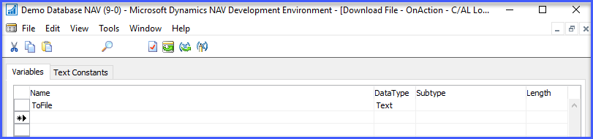

* **Added Code in action ”Download File”.**

CompanyInformation.GET;

AzureTest := AzureTest.AzureUpload;

ShowStatus := AzureTest.DownloadBlob(Rec."File Name",CompanyInformation."Download Path"+Rec."File Name",

CompanyInformation."Account Name",CompanyInformation."Account Key",CompanyInformation.Container);

MESSAGE('%1',ShowStatus);

ToFile := FileMgt.GetFileName(CompanyInformation."Download Path"+Rec."File Name");

DOWNLOAD(CompanyInformation."Download Path"+Rec."File Name",'Download file','','Text file(*.txt)|*.txt',ToFile);

**Step 14. After that create action ”Delete File” on new page.**

* **Added Local Variable in action” Delete File.**

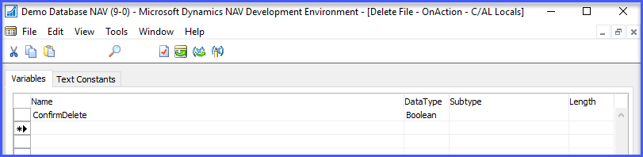

* **Added Text Constants in action” Delete File.**

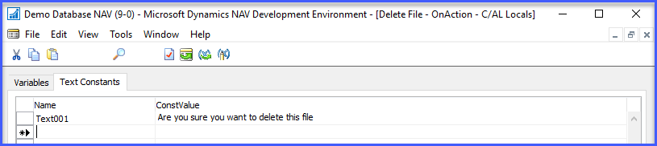

* **Added Code in action ” Delete File”.**

CompanyInformation.GET;

ConfirmDelete := DIALOG.CONFIRM(Text001,FALSE,TRUE);

IF ConfirmDelete = TRUE THEN BEGIN

AzureTest := AzureTest.AzureUpload;

ShowStatus := AzureTest.DeleteBlob(Rec."File Name",CompanyInformation."Account Name",CompanyInformation."Account Key",CompanyInformation.Container);

Rec.DELETE;

MESSAGE('%1',ShowStatus);

END;

**Step 15. Added Code in item list page on “OnAfterGetCurrRecord” Trigger.**

CurrPage.AzureDownloadListPart.PAGE.setvalue(Rec."No.");

**Step 16. Added your new page in part for show in Factbox in item list page.**

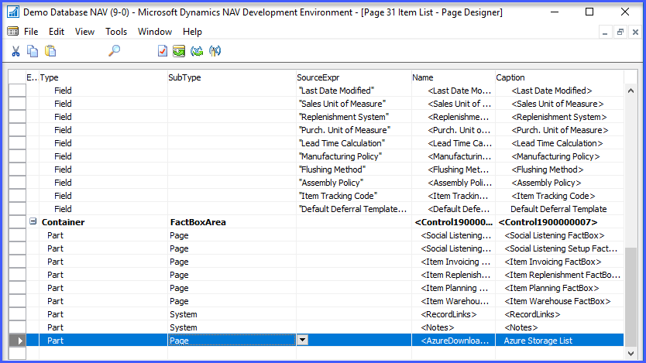

**Step 17. After that follow this**

* **open Item List and in Azure Storage List fact box**
* **Click Action on “Upload to Azure “**
* **Choose a file for upload on azure storage**
* **After that click on open**

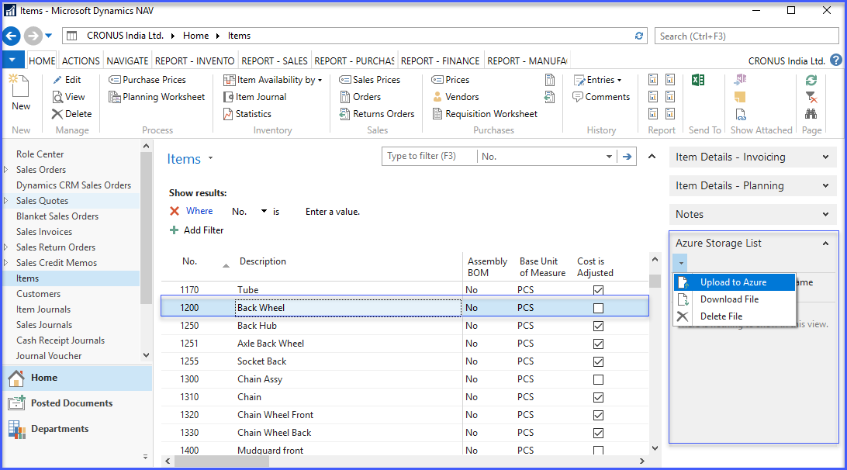

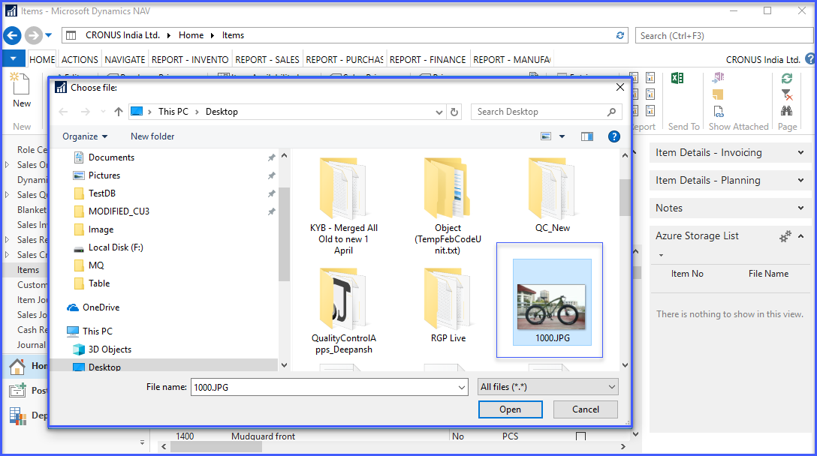

* **You can see this** File Upload Successfully **Message. Your file successfully uploaded on your azure storage.**

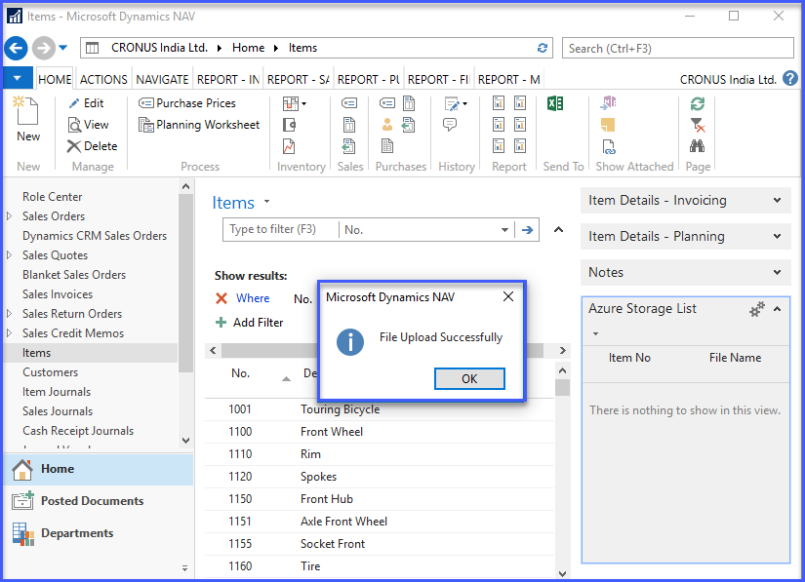

* **Selected file uploaded and attached with selected item in factbox.**

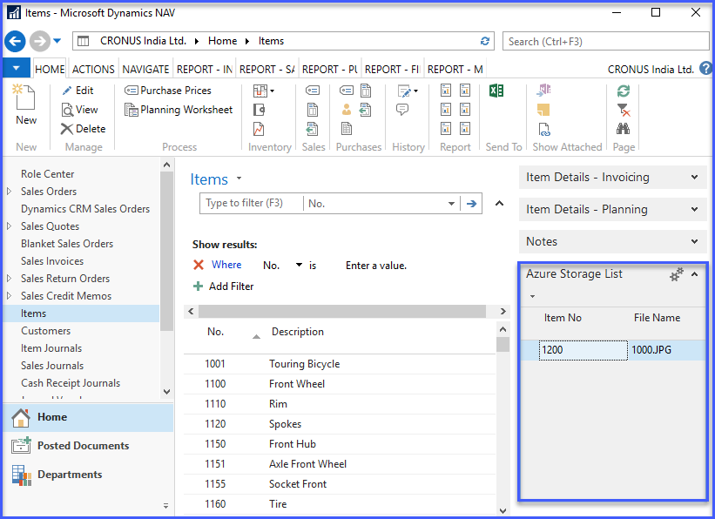

* **Now you can see in your azure storage account you find uploaded file**

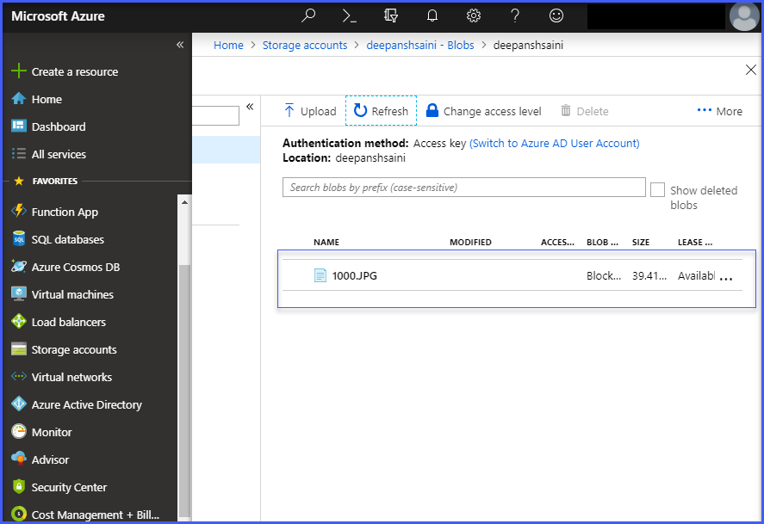

**Step 18. Select a file in fact box and Click on “Download File “ Action**

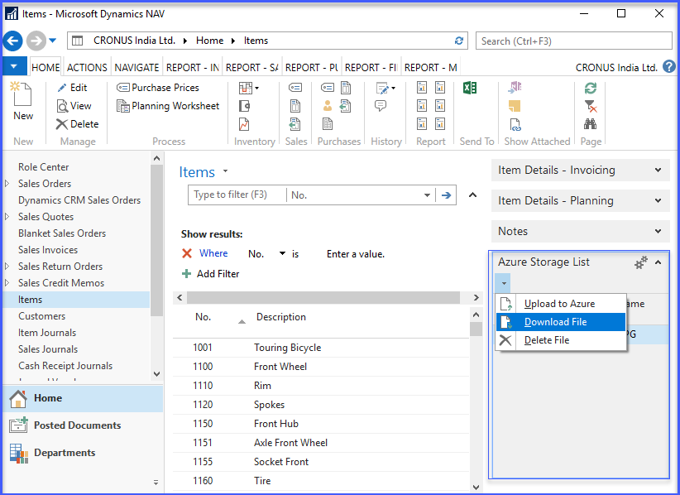

* **After click on Download File action you can see Open and Save Option.**

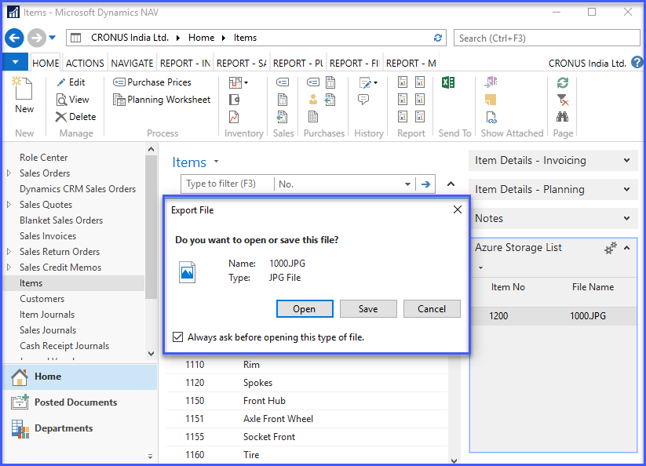

* **Click on Save Button and select location for save a file from Azure Storage.**

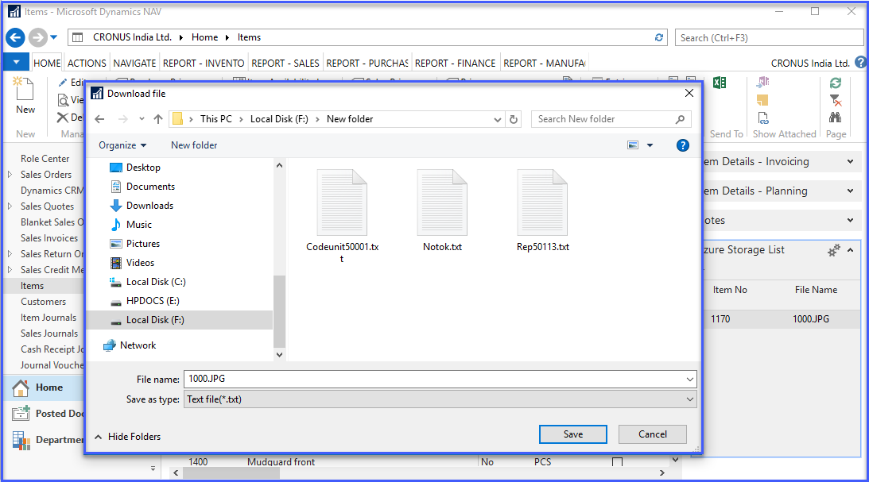

* **You can see this** File Downloaad Successfully**Message. Your file successfully uploaded on your azure storage.**

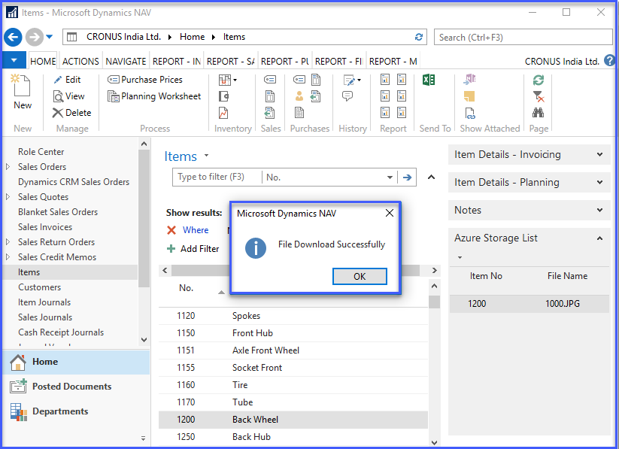

* **After that click on save button now you can see file.**

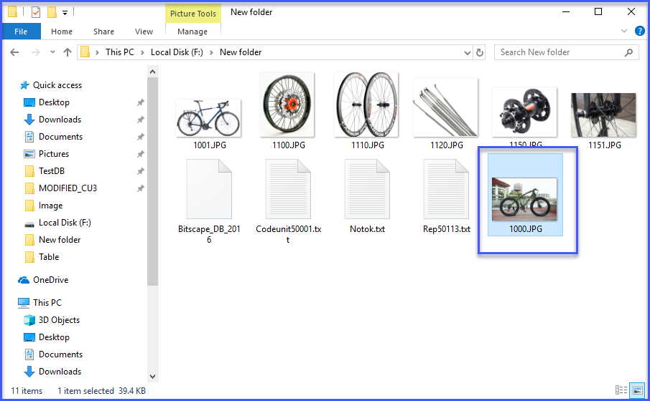

**Delete File from Azure Blob Storage**

* **Select a file you want to delete in factbox list**

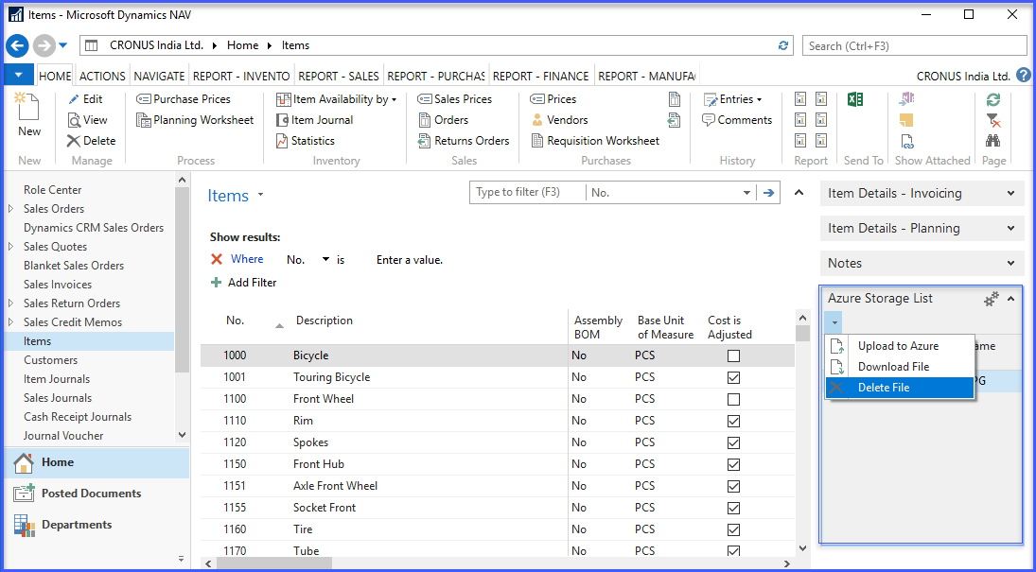

* **Click on “Delete File” Action**
* **Now you can see a Confirm Dialog with Yes and No option**

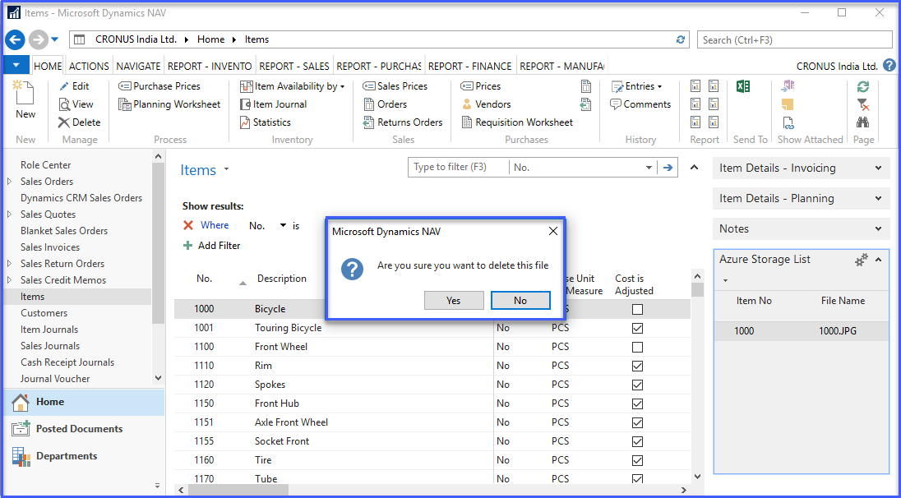

* **You can see this File Deleted Successfully Message. Your file successfully Deleted in your azure storage.**

